GUJARAT TECHNOLOGICAL UNIVERSITY Chandkheda, Ahmedabad

Affitiated



**Apollo Institute of Engineering**

Anasan, Ahmedabad

A Report on-

**Smart Shopping**

Under subject of

DESIGN ENGINEERING – 2A B. E. Semester –5th Computer Engineering

|  |  |  |
| --- | --- | --- |
| **Sr.** | **Name of Student** | **Enrollment No.** |
| 1. | Patel Jaimin | 151280107038 |
| 2. | Patel Yash | 151280107042 |
| 3. | Ramani Ravi | 151280107045 |
| 4. | Soni Ram | 151280107055 |

Asst. Prof. Kajol Soni

**(Department of Computer Engineering)**

Asst. Prof. Naveen Kandwal

**(Head of Department Computer**

**Engineering)**

**CERTIFICATE**

**Date:**

This is to certify that the project entitled “Smart Shopping**”** has been carried out by

“Patel Jaimin (151280107038), Patel Yash (151280107042),

Ramani Ravi (151280107045), Soni Ram (151280107055)” under my guidance in fulfillment of the Design Engineering – 2A, - 5th Semester, Degree of Bachelor of Engineering in Computer Engineering of Gujarat Technological University, Ahmadabad during the academic year 2016-2017.

**Name of Guide Head of Department**

Asst. Prof. Kajol Soni Asst. Prof. Naveen Kandwal

**CANDIDATE’S DECLARATION**

We have finished our project report entitled “**Smart Shopping**” and submitted to our respective guide. We are in 4th semester and we have tried to give our best. We have done our work honestly and in a good way.

First Candidate’s Name : Patel Jaimin

Branch : Computer Engineering

Enrollment No. : 151280107038

Signature :

Second Candidate’s Name : Patel Yash

Branch : Computer Engineering

Enrollment No. : 151280107042

Signature :

Third Candidate’s Name : Ramani Ravi

Branch : Computer Engineering

Enrollment No. : 151280107045

Signature :

Fourth Candidate’s Name : Soni Ram

Branch : Computer Engineering

Enrollment No. : 151280107055

Signature :

Submitted to:

Apollo Institute of Engineering

Anasan, Ahmedabad

**ACKNOWLEDGEMENT**

MatWithData would have Candidate registration, document verification, auto-generated User ID

and pass for candidate and Voters. Admin Login which will be handled by Election Commission

.Candidate Login which will be handled By Candidate, Voters will get Unique ID and Password, Using which they can vote for a Candidate only once per Election. The project is beneficial for Election Commission, Voters as the can get to know the candidate background and choose wisely, and even for Candidate. The software system allows the Candidate to login in to their profiles and upload all their details including their previous milestone onto the system. The admin can check each Candidate details and verify the documents, only after verifying Candidate’s ID and Password will be generated, and can remove faulty accounts. The software system allows Voters to view a list of Candidates in their area. The admin has overall rights over the system and can moderate and delete any details not pertaining to Election Rules.

**INDEX**

|  |  |  |
| --- | --- | --- |
| **Sr. No.** | **Topics** | **Page**  **no.** |
| **1.** | **Introduction** | **1** |
|  | 1.1 What is design thinking |  |
| **2**. | **Empathizing Canvas** | **2** |
|  | 2.1 Deciding users | **2** |
|  | 2.2 Stack holders | 3 |
|  | 2.3 Activity | 4 |
|  | 2.4 Story |  |
|  | 2.4.1 Happy story | 5 |
|  | 2.4.2 Sad story | 6 |
| **3.** | **Ideation canvas** | **7** |
|  | 3.1 People | 8 |
|  | 3.2 Activities | 9 |
|  | 3.3 Situations / Context / Location | 10 |
|  | 3.4Props/ Possible solution | 11 |
| **4.** | **Product development canvas** | **12** |
|  | 4.1Purpose | 13 |
|  | 4.2 People | 14 |
|  | 4.3 Product experience | 15 |
|  | 4.4 Product functions | 16 |
|  | 4.5 Product feature | 17 |
|  | 4.6 Component | 18 |
| **5.** | **AEIOU FRAMEWORK** | **19** |
|  | 5.1 Activity | 19 |
|  | 5.2 Environment | 20 |
|  | 5.3 Interactions. | 21 |
|  | 5.4 Object | 22 |
|  | 5.5 User | 23 |
| **6.** | **Flowchart** | 24 |
| **7.** | **Phase 1&2** | 25 |

**1. Introduction**

**1.1 What is Design thinking?**

Design Thinking is a methodology used by designers to solve complex problems, and find desirable solutions for clients. A design mindset is not problem-focused, its solution focused and action oriented towards creating a preferred future. Design thinking draws upon logic, imagination, intuition, and systemic reasoning, to explore possibilities of what could be—and to create desired outcomes that benefit the end user (the customer).

**2 .Empathizing Canvas**

Empathy Mapping Canvas is made up of USERS (Who uses the product), STAKEHOLDERS (Who have the ownership of product), and ACTIVITIES (What kind of works can be done by this product).

**2.1 :Deciding users:-**

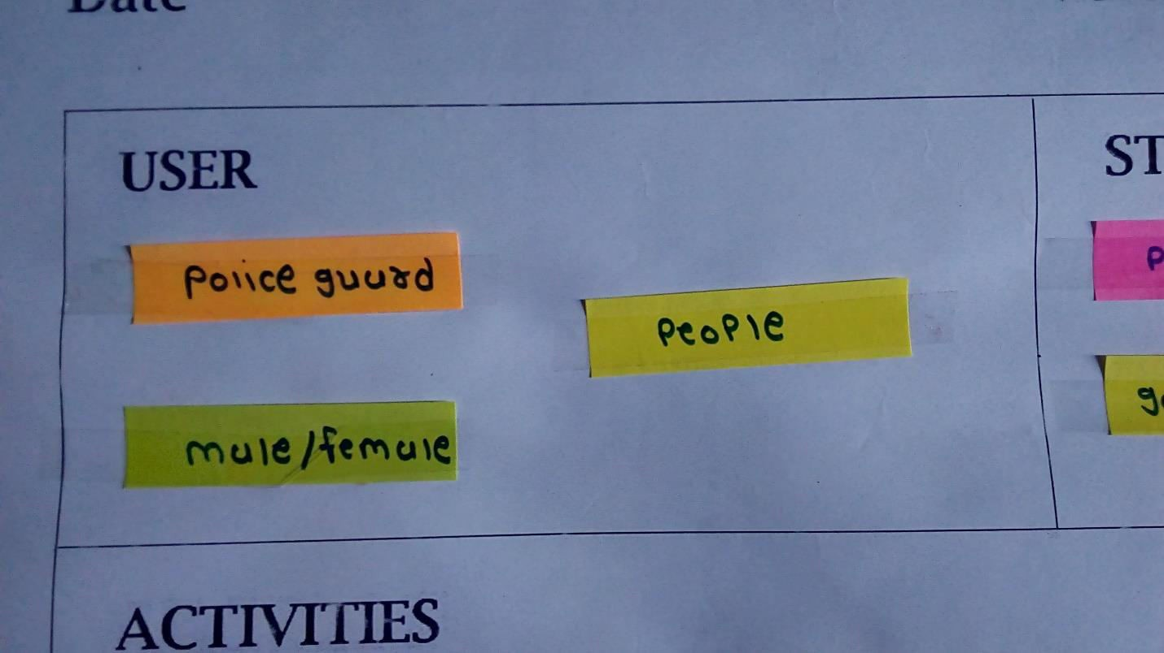

guard , people male/female etc. Which is part of this activity.

For our topic MatWithData , there are some users like police

**2.2 :Stack holders:-**

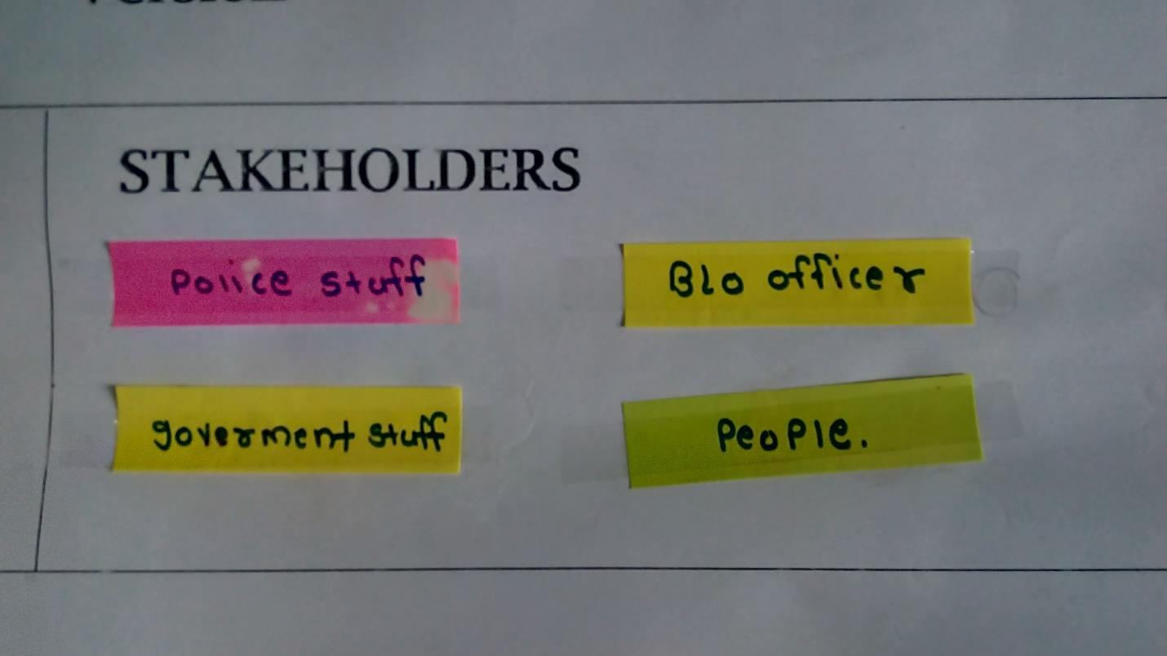

We have different type of stakeholders likepolice staff, BLo officer, Government staff, people. etc.

**2.3 : Activity:-**

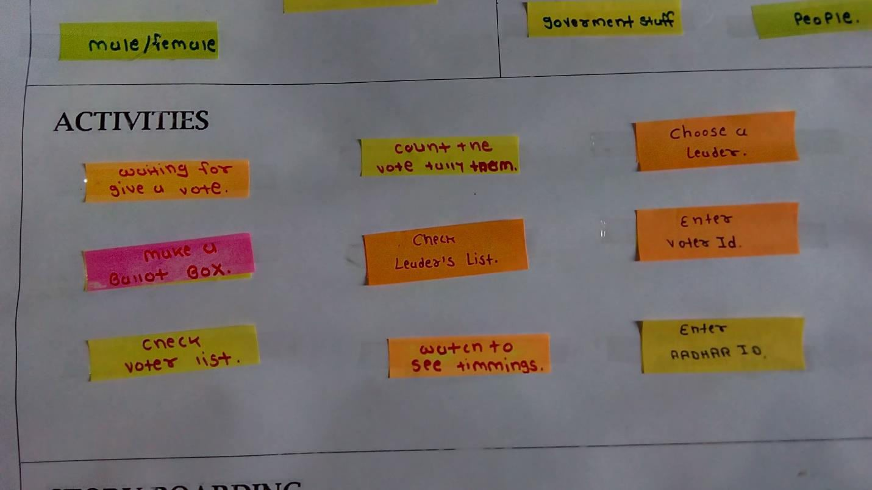

This are the activity which responsible for failure of our purpose.

These are the activity which responsible for failure of work we want to complete and also identify which things get involves in this activity.

There are so many activities like check voter list, check leader list, enter voter id,Enter Aadhar id etc.

**2.4: STORY:-**

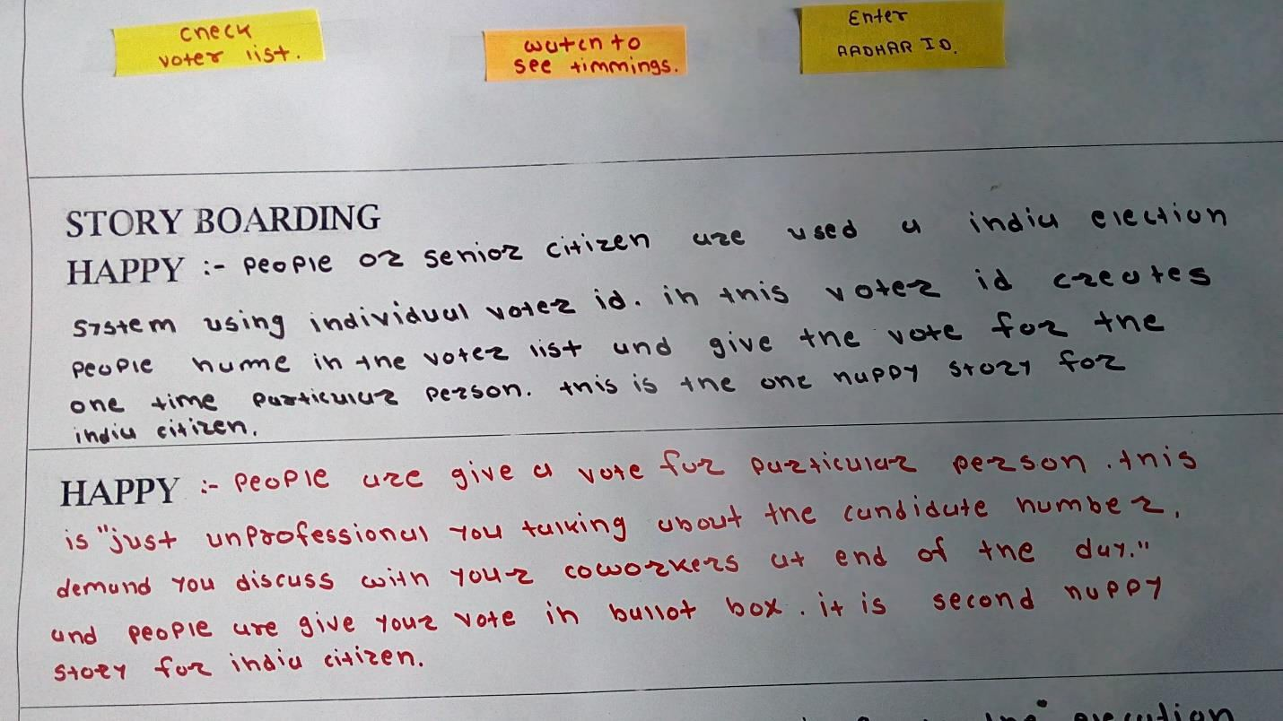

**2.4.1:Happy story :**

**2.4.2: Sad Story:**

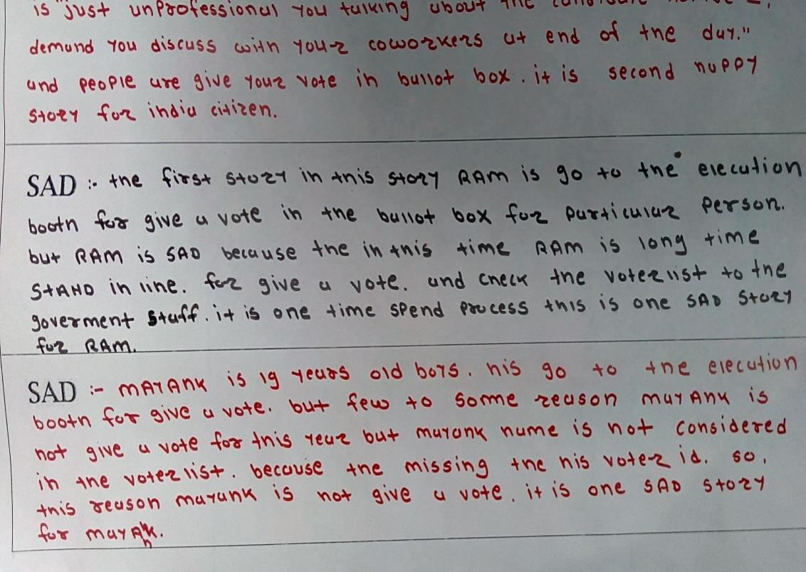

Design Engineering-2A Page 6

**3 - Ideation canvas**

An **ideation canvas** is a rough whiteboard where ideas can be stretched into any limits or dimensions. **Ideation** session is not aimed at finding solutions to the defined problem. But to define the best possible problem and stretch out it’s possible.

Ideation canvas is made up of PEOPLE (Who can use), ACTIVITIES (What kind of works can be done by this product), SITUATION /CONTEXT

/LOCATION (On which place this technology can be use), PROPS

/POSSIBLE SITUATIONS.

**3.1:People:-**

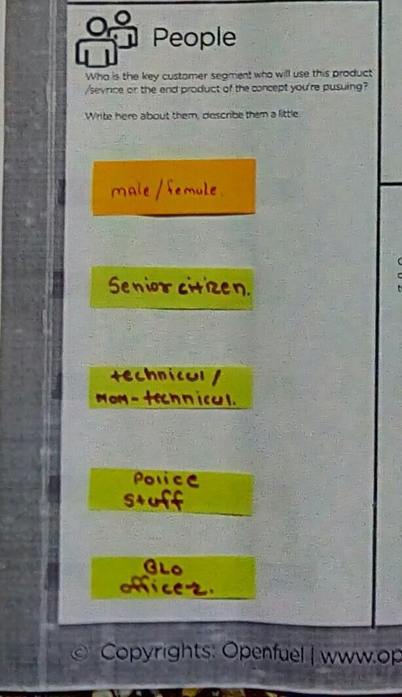

Looking forward a set of different people involved was peeped into. We

came out with following idea on involvement of people.

People are the users associated with the application.

There are so many people senior citizen,BLO officer, technical-non technical person etc.

**3.2 :Activities:-**

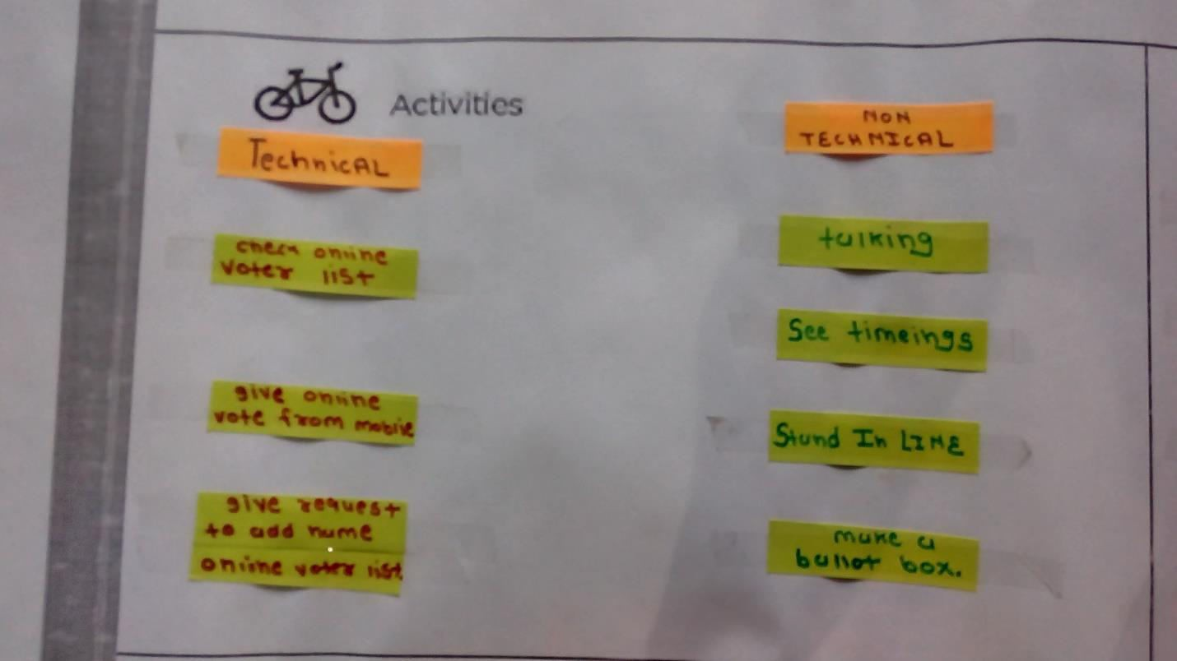

With the thought on people involved in different activities, an attempt was made to think up in possibilities of various activities. Elaboration at maximization is essential here at the stage while identifying activities.

Activities are check voter list, give a vote to leader, enter Aadhar id etc.

**3.3:Situations / Context / Location:-**

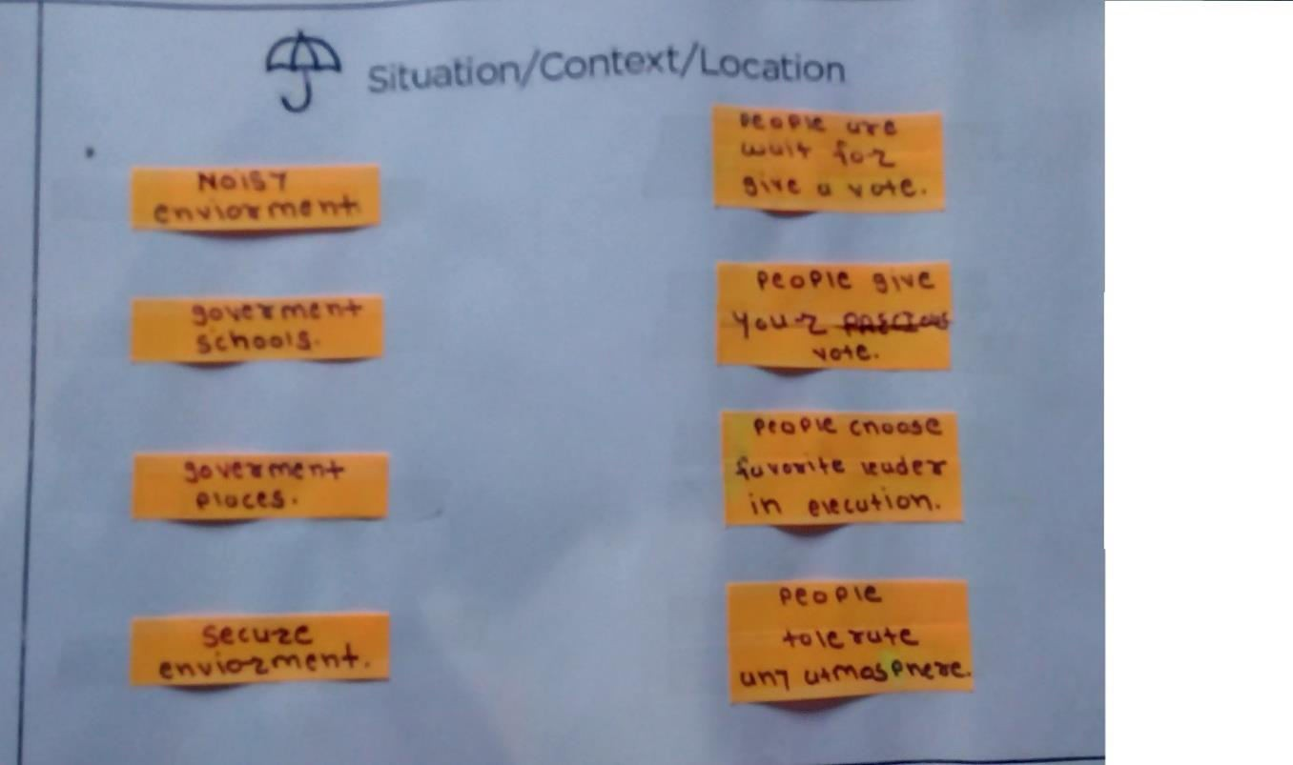

With the number of people identified doing many activities, we attempted to identify different locations that are involved in performing such activities , situations that are applied to perform certain activities and context of importance that was relevant to activities .different type of ideas we came up with the following.

Situations noisy environment, government school, government places,

etc.

**3.4: Props/ Possible solution:-**

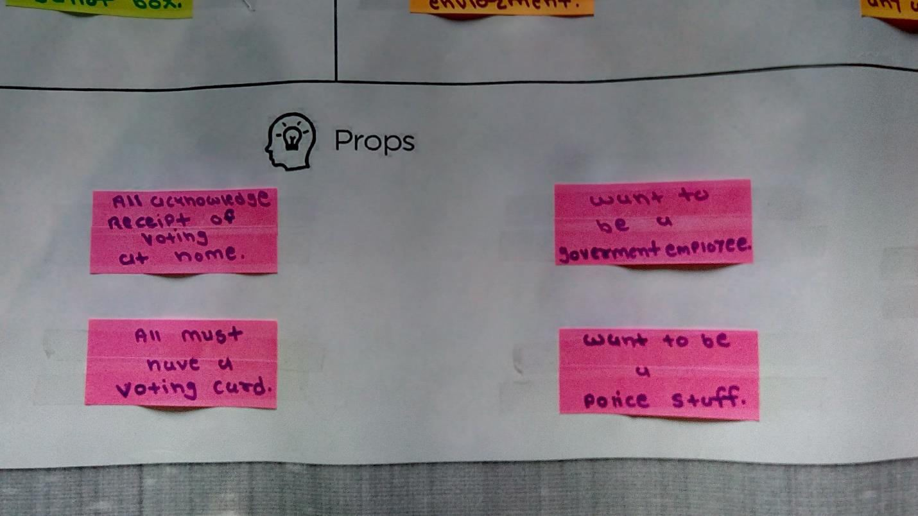

This section of the ideation canvas help in carving out different requirement in –line with attempting / looking forward to have an idea about addressing a problem some of the solution regarding to problem as below.

Various props like want to be a government employee, all must have a voting card etc are necessary.

**4 - Product Developing Canvas**

A product development canvas is the ground where in the best possible ideas after the ideation session are pitched and nurtured to develop.

Product development canvas made up of PURPOSE (Why this technology needs to be invented), PEOPLE (Who can use), PRODUCT EXPERIENCE (How is experience by using this product), PRODUCT FUNCTIONS (Main functionality of this product), PRODUCT FEATURES (features of this product), COMPONENTS (What kind of hardware/software has been used),

/feedback), REJECT/REDESIGN/RETAIN (Decision or advice of customer). REVALIDATION

**4.1:Purpose:-**

In this we have described the purpose of making this product. Why we are making this product. What’s our main aim?

(i) Secure process

(ii) Chance to people to give a vote

(iii) Continues process

(iv) Chance to choose leader

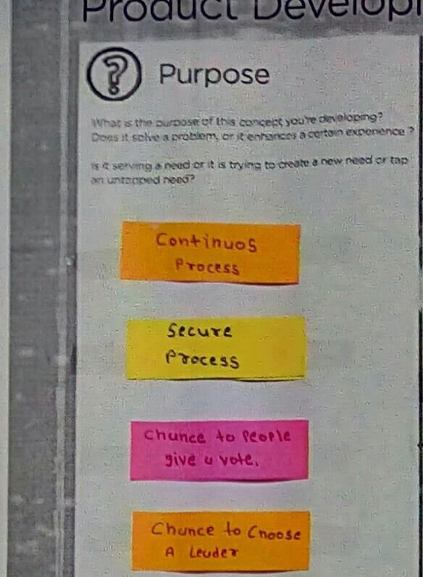

Design Engineering-2A Page 13

**4.2:People:-**



This portion contains the user who can use this product.

To whom this product is useful.

**4.3:Product Experience:-**

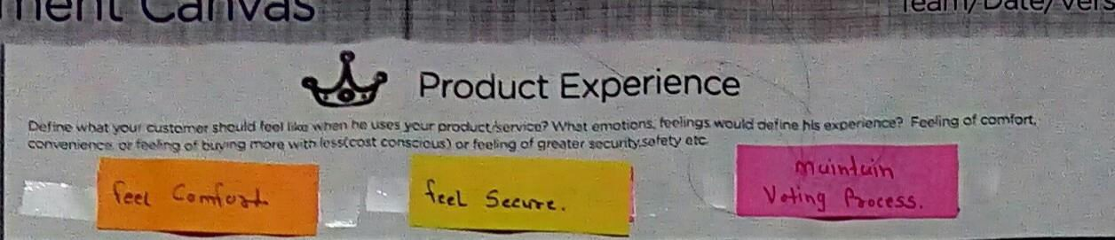

In this section we now that how the people felt who used our product.

**4.4:Product function:-**

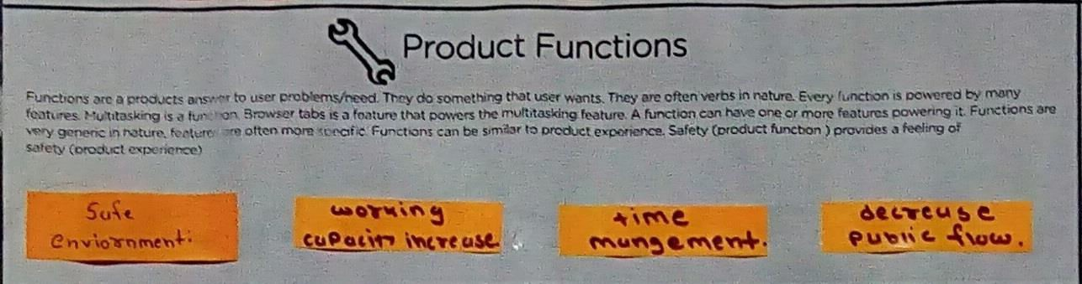

Product Function includes how product will be helpful other than it features.

(i) Safe environment

(ii) Time management

(iii) Working capacity increase

**4.5:Product features:-**

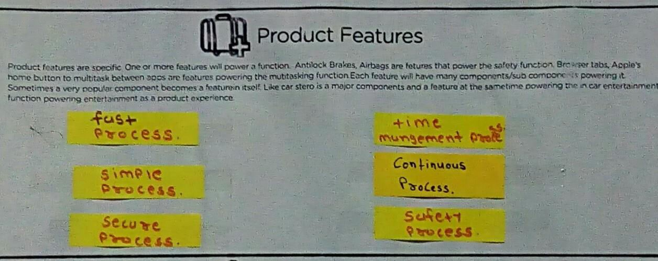

Features of the Product are included in this section. What are the options, specifications of the Product are known as Product Features.

(i) Fast process

(ii) Time management process

(iii) Simple process (iv) Secure process (v) Safety process

**4.6:Components:-**

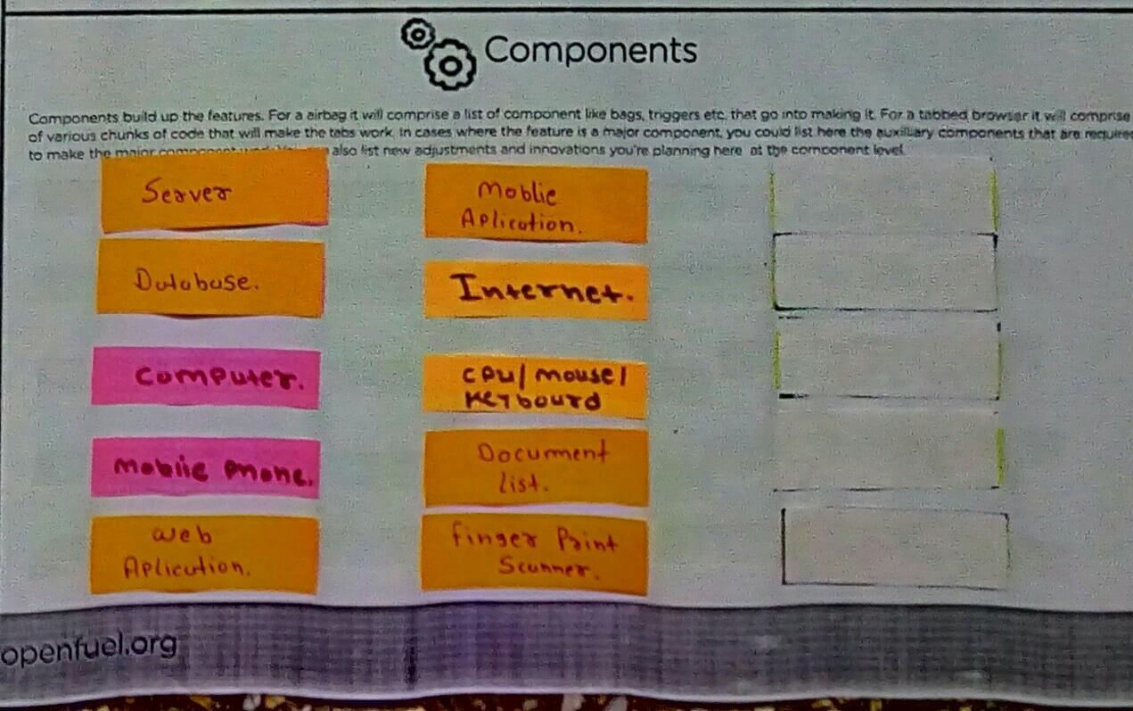

The Components which are used in making the product are included in this

(i) internet

(ii) Database

(iii) Mobile phones

(iv) Web application

**5:-AEIOU FRAMEWORK**

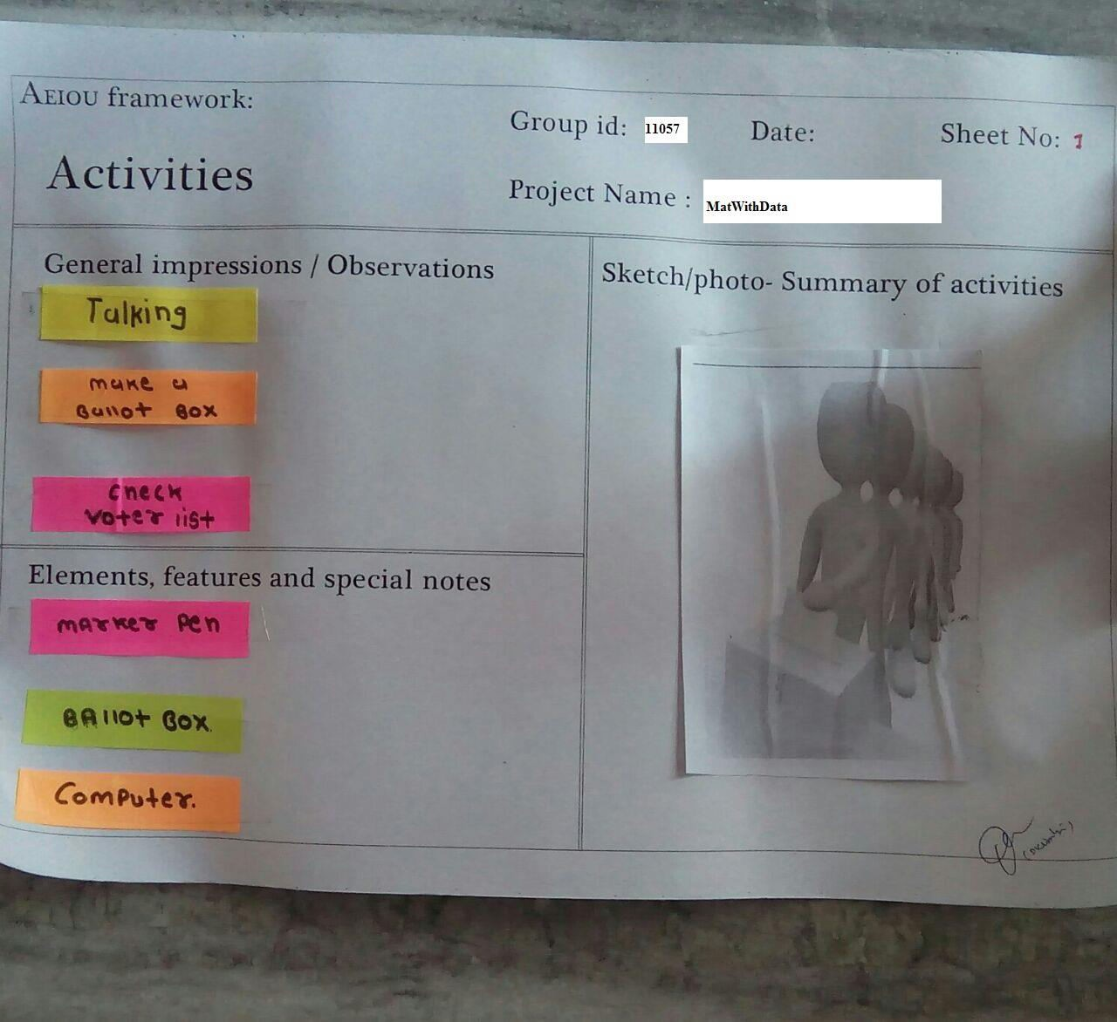

**5.1:Activities:-**

This portion contains the collection of all the activities which we have observed from first day till the last day of our observation.

**5.2: Environment:-**

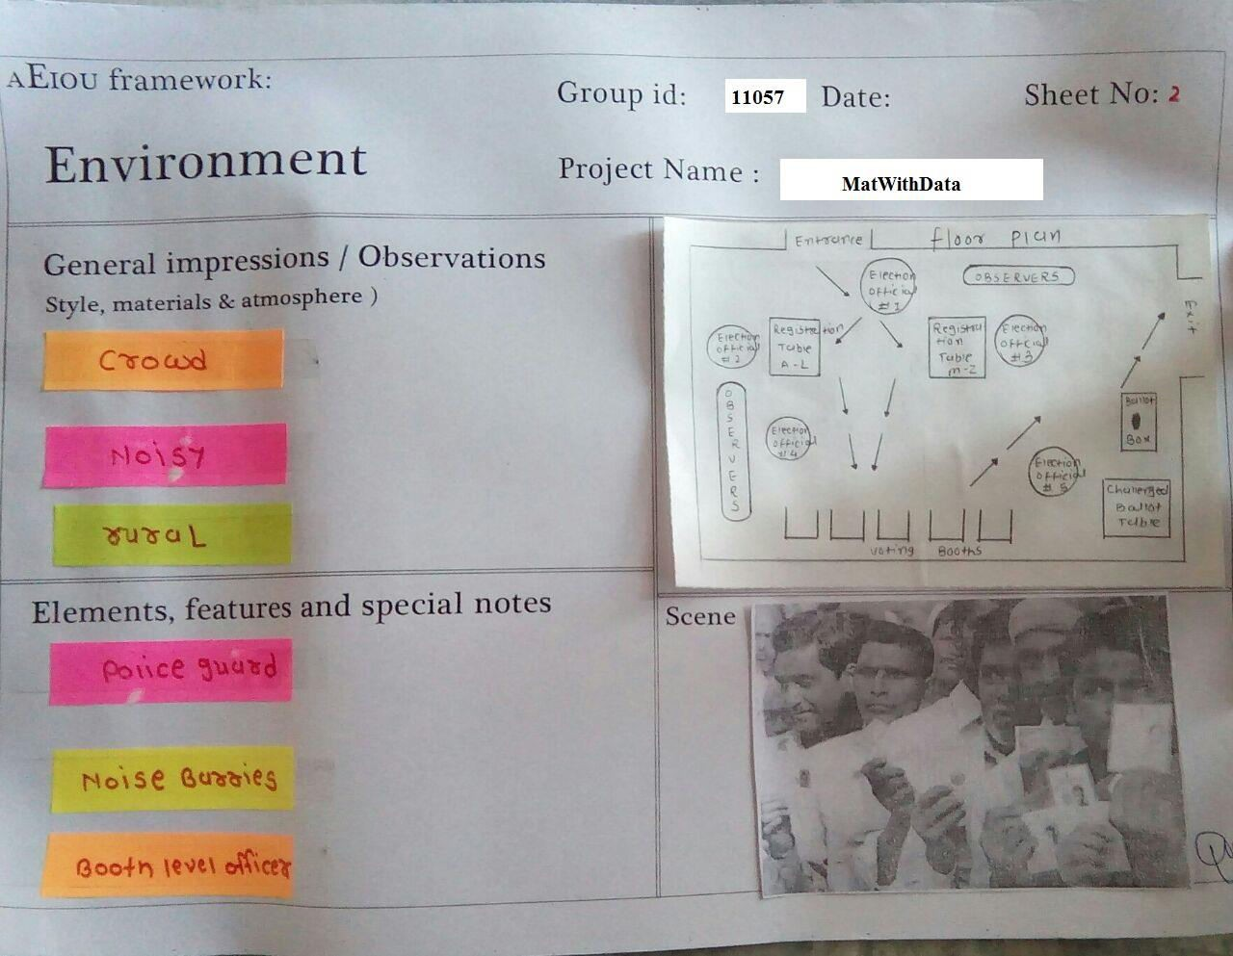

Design Engineering-2A Page 20

**5.3:Interactions:-**

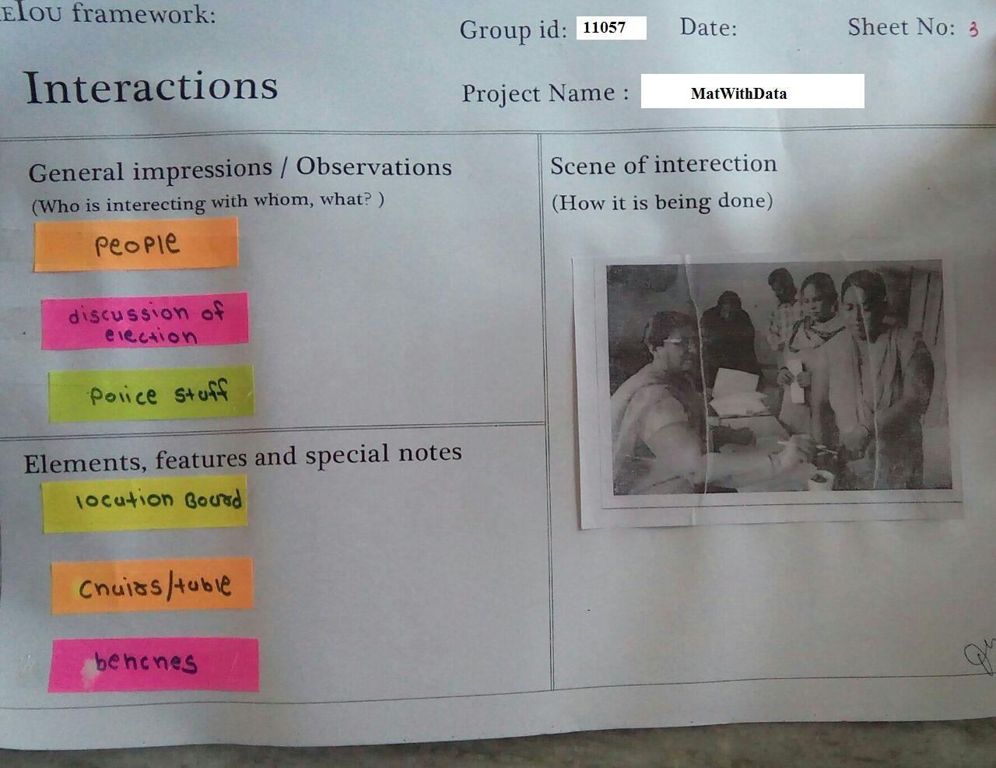

Interaction between customers and video company is very important part of framework.

This includes the conversation which we have done with people, objects during observation, and also the other people were doing.

**5.4: Objects:-**

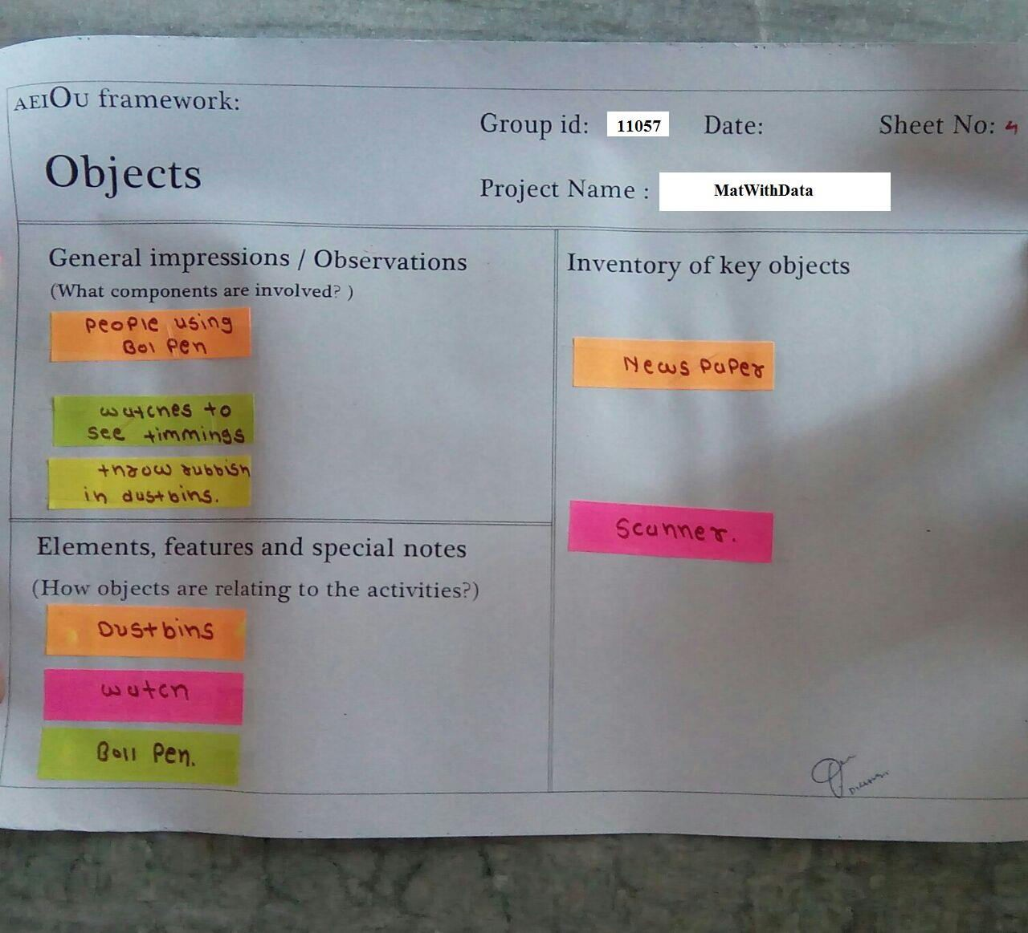

This Section is completely filled up with all the nonliving things. Through this section we could also know many things.

From this section we could know how different objects play role in the process and which also show the possibility of the problems.

**5.5:Users:-**

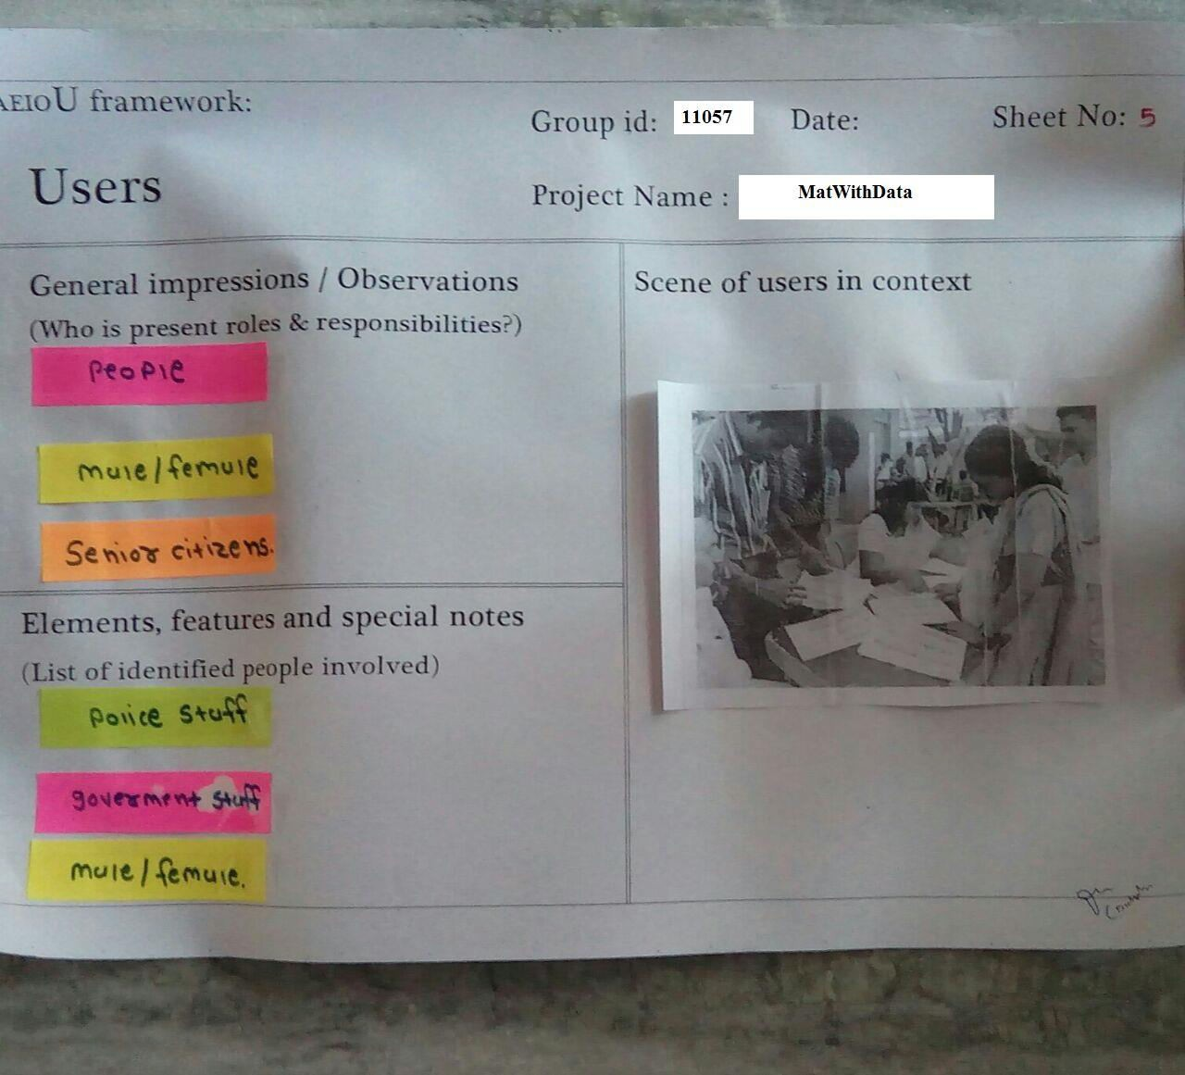

Users are the person which are involved during the observation and in the observation. They are the person who have played the roll.

**6 - Flowcharts**

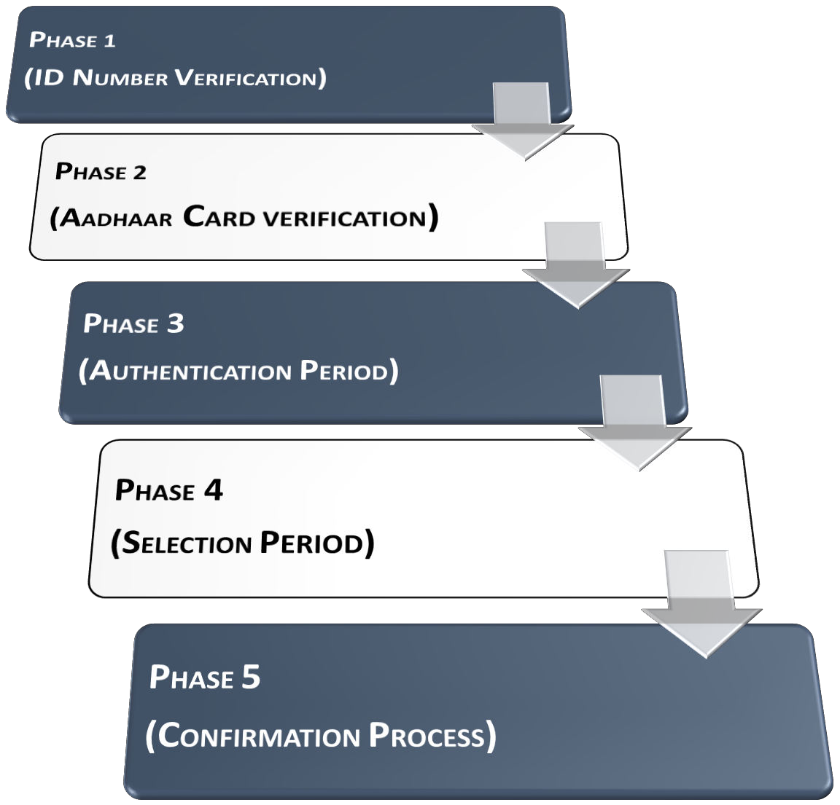

Design Engineering-2A Page 24

**7 -Phase 1,2**

**Phase 1 (Id Number Verification)**

**1. Requesting Confirmation**

**2. Confirmed**

**Server**

**DB1**

**3.**

**Passed to Aadhaar**

**Card Verification 4.**

**Aadhaar Card**

**Confirmation**

**Phase 2 (Aadhaar Number Verification)**

**5. Confirmed**

**6. Passed to Authentication Period**

**Phase 3 (Authentication Period)**

Design Engineering-2A Page 25